TECHNICAL SPECIFICATION SIGNOFF FORM
IT-FRM-006/2550

APPLICATION : ………SD…………………………… | SCR / DPR NUMBER : …2017-1-0014…………………
TOPIC / FUNCTION : …Monetary Service – Deactivate Reprint Monetary transaction
DATE RAISED : ……06/01/2017……………………………………
CODE MODS REQUIRED (Y/N) : …Y……… | Magnitude of Mods (S/M/L/XL) : …M ……  S = 1-2 Wks, M = 3-5 Wks, L = 5-10 Wks, XL = OVER 10 Wks
AFFECTED APPLICATION : ……None………………………………………………………
SPECIFICATION DESCRIPTION :
ACE Server
- No change
SD Server
- Modify SD Server Common modules to interface to ETE
  - Modify /tp/tpTransaction/tpDTransaction.cpp by adding new functions InitializeEteGateway, InitializeEteWsData, ExtractValueByTag and InvokeEteGateway to support ETE transaction
  - Modify /tp/tpTransaction/tpDTransaction.cpp by updating function ‘Post’ support ETE transaction
  - Modify header file by adding function definition to tpDTransaction.h and tpPTransaction.h required by source files
  - Modify /tpTransaction/tpPTransaction.cpp by updating SaveTransactionToDatabase, Add, GetHostReplyStatus
- Create new ETE configuration, header and source file eteGateway.cfg, bcEteGateway.cpp, bcEteGateway.h, ETEWSData.h for
  - Web Service interface
  - Communication with ETE
  - Configurable. WS endpoint. Communication method
- Create scripts to extract GL events records to FTP server
  - main_glexpense.sh this is main script that would be executed by CRON on 11:00 pm daily basis (e.g. 0 23 * * * /scripts/SD_GLExpense/main_glexpense.sh)
  - exportGLExpense.sh, the script to execute sql
  - mailit.sh, the script would send email to whom may concern configured in the script if any error occurs
  - exportGLExpense.sql, sql script to extract GL events records to file
  - ftp_file.sh, transfer file to target FTP server
SD Client
- Modify SDClient, AaiAPrintableWindow_PrintEnabled and AaiAPrintableWindow_PrintWindow function to enable or disable print menu. The modules below has to modify these two functions:
- bpPayment, drCnclRevDROutw, drInwardPayment, drOutwRemittance, fxFoMoExch, lbCancelPayment, lbCnclClrLiabPmt, lbPayment, lbRollOver, twLoan, twMonetaries, and twPassbook.
- AaiAPrintableWindow_PrintEnabled function, this function will call twSupport module to enable or disable print menu.
- AaiAPrintableWindow_PrintWindow function, this function will call twPrint to print receipt.
  - Create “PRINTFLAG” and set value to ‘Y’ to indicate that this transaction should print receipt only one time.
  - After calling twPrint module to print receipt, it will remove data from “PRINTFLAG”
- Modify twSupport module to enable or disable print button on menu when those modules on above are calling. The print button will be enabled when match the criteria below:
- Transaction Processing Date should be same as processing date
- The drawer id who opens transaction from journal should be same as drawer open do the transaction.
- The transaction should be reversal transaction which never prints receipt by inquiry data from DEBITCREDIT table in GLDESCRIPTION field.
  - If DEBITDCREDIT.GLDESCRIPTION = ‘Y’, it means this transaction prints receipt already
  - Otherwise, the transaction does not print receipt yet.
- Modify twPrint module to checking print receipt only one time.
- Checking the “PRINTFLAG” is equals ‘Y’ or not.
  - If “PRINTFLAG” is equals ‘Y’, it will set DEBITDCREDIT.GLDESCRIPTION = ‘Y’ after print receipt
  - Otherwise, it will print receipt without set value in GLDESCRIPTION field.
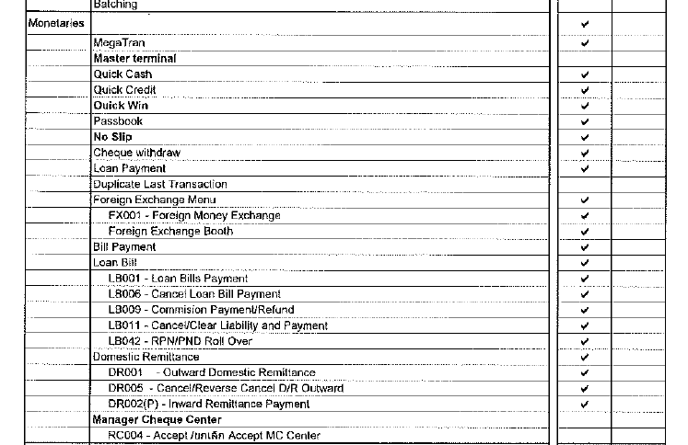

Updated File Name
- bpPayment.dll
- drCnclRevDROutw.dll
- drInwardPayment.dll
- drOutwRemittance.dll
- fxFoMoExch.dll
- lbCancelPayment.dll
- lbCnclClrLiabPmt.dll
- lbCommPmtRefnd.dll
- lbPayment.dll
- lbRollOver.dll
- twLoan.dll
- twMonetaries.dll
- twPassbook.dll
- twPrint.dll
- twSupport.dll

Database
- No change structure of DEBITCREDIT table, it just use GLDESCRIPTION field to keep print flag to indicate that this transaction is print already.

TECHNICAL ANALYST :  Name : ……Suchinda Lerdkeeratiwanich…………... (Fidelity)……  Signature : …………………………………………………………… | PROJECT TECHNICAL APPROVAL :  Name : …K.Sunee Thongchot.................………………………  Signature : …………………………………………………………

